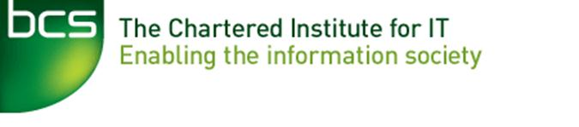

Minutes of BCS Bedford Branch

Annual General Meeting 2016

Held in the Tavistock Suite, The Park Inn Hotel, St Marys St, Bedford, MK42 0AR

On Tuesday, 20th September 2016 at 8.00pm

Present:
Ip-Shing Fan | Chairman / Education Liaison | IF
Saverio Bongo | Secretary / Email Co-ordinator | SB
Ian Wilson | Webmaster | IW
Chris Ireland  Bob Bethell | Committee Member  Committee Member – Schools Project | CI  BB
Plus all members of | the audience who attended the FORTAN talk.

- Apologies for Absence
Richard Maddision (RM), Sue Brandreth (SB1)

- Minutes of Last AGM Meeting
The Minutes of the 2015 AGM were APPROVED as a true record.

- Matters Arising
There were no matters arising not covered by the 2016 AGM Agenda.

- Chairman’s Report
See attached Chairman’s Report

- Treasurer’s Report
On behalf of the Treasurer (RM) the Chair reported the Branch had another successful year with the number of talks plus keeping well within the budget constraints set by BCS HQ. We look forward to a filled diary in 2016 with interesting and thought provoking talks.
- Secretary’s Report
See attached Secretary’s Report.

- Election of Committee
Call for nominations was issued in the summer and an online election planned. However, the number of nominations received was low and no election was necessary. The following officers were declared as ELECTED

The Elected Officers for 2016 were as follows:

Position | Appointed
Chairman/ Email Co-ordinator | Ip-Shing Fan
Secretary/Email  Co-ordinator | Saverio Bongo
Treasurer | Richard Maddison
Webmaster | Ian Wilson
Membership Secretary/ Education Liaison Officer | Sue Brandreth
Committee Member | Chris Ireland
Committee Member / Schools Project | Rob Bethell

The Chairman would like to thank everyone and acknowledge the support the Bedford Branch received from all the Committee Members:

- Any Other Business
None

The Chairman declared the formal AGM meeting closed at 20:25

Guest Speaker – Peter Crouch | Chairman, BCS Fortran Specialist Group on the topic of “Fortran, alive and well at 59! “

The chairman thanked the Guest Speaker for sharing the evolution and sustainability of the Fortran Programming Language over so many years and used in so many niche industries.

SB.AGM2016Minutes 28Sept16.

